Assignment – 7

Question 1 . Write a query that counts all orders for 3rd october.
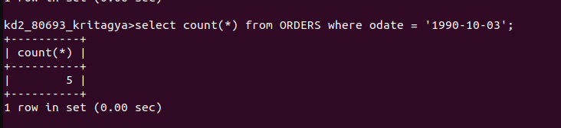
Question 2. Write a query that counts the number of different non-Null city values in the customers table

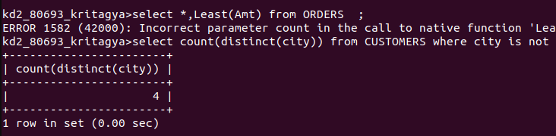
Question 3. Write a query that selects each customer’s smallest order.
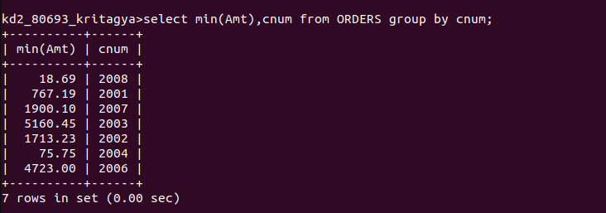
Question 4. Write a query that selects the first customer, in alphabetical order, whose name begins with G.

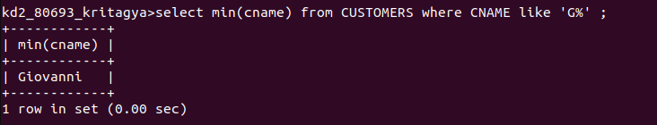
Question 5. Write a query that selects the highest rating in each city.

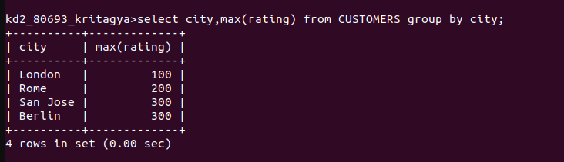
Question 6. Write a query that counts the number of salespeople registering orders for each day.

